Bagirishya Rwema Dominique & Nshuti Elise

**embedded SYSTEM DEVELOPMENT - 04633-A**

**FINAL PROJECT PROPOSAL**

**Smart water meter**

Table of Contents

Introduction 2

Project Objectives 2

Milestones: 3

Methodology 3

Expected outputs. 3

List of components 4

Conclusion 5

Reference 6

# Introduction

This proposal summarizes the concept of our final year project, called 'Smart Water Meter', in embedded systems development at Carnegie Mellon University Africa. It will be developed by Bagirishya Rwema Dominique and Nshuti Elie.

The proportion of the Rwandan population with access to improved drinking water sources increased from 77% to 87% after 2005 and According to the latest Integrated Household Living Conditions Survey, EICV3 report, the proportion of Rwandan households using surface water (rivers or lakes) as drinking water has decreased from 18 to 12 per cent over last five years. [1]

This exemplifies that over 87% of institutions and organizations still use an analog method to pay their water bills. Currently, there is no digital system that WASAC Company can utilize to manage and collect revenues from these customers, other than deploying their workers to each household in the country to collect those bills. This current system is unconventional, analog, and costly for the water supplier company, as it demands significant effort and a large workforce. Additionally, from the customers' perspective, it is ineffective, often leading to complaints about receiving unfair bills that do not accurately reflect the amount of water consumed. [2]

# Project Objectives

The project aims to introduce several innovative solutions through the implementation of a new system known as the Smart Water Meter. This system is designed to revolutionize the way water is purchased, allowing customers to buy water based on the quantity they desire. A significant objective of this initiative is to assist the WASAC Company in streamlining its operations by reducing the need for a large workforce currently deployed to collect payments from customers. Additionally, the project seeks to enhance the company's ability to gain deeper insights into their billing and water consumption patterns on a monthly and yearly basis, facilitating a digital approach to analyze these aspects. Additional goal is to address and eliminate the prevalent issue faced by customers, where their water supply is locked due to delayed payments, thereby improving customer satisfaction and service reliability.

# Milestones:

Firstly, we intend to develop a web platform that will serve as the centerpiece of the project, particularly for administration purposes. This is expected to take up 50% of the time allocated for this project.

Secondly, we will also develop a USSD code that will enable functions such as purchasing water, checking water balance, and managing account settings. Time permitting, we will add a new feature that allows customers to borrow water, provided they are in good standing and in this phase, we plan to integrate APIs.

Thirdly, we will be developing our STM32 project, which will primarily focus on:

* Initialization of all components,
* Web communication, enabling the system to communicate with the server to fetch the initial water limit and update the server on current water usage,
* Relay control for managing water supply,
* Wi-Fi connection, which is essential for making HTTP requests to send or receive data from a web server,
* Display information, where the LCD display will show various messages and the volume of water in litters as measured by the sensor."

Lastly, we will integrate all these components to ensure the system functions seamlessly.

# Methodology

The methodology we adopted for this project entails a multifaceted approach aimed at developing an efficient embedded system to address the identified objectives. Utilizing the Agile methodology, [3] we will embark on the development of a web-based platform designed to serve as the central control hub for managing and monitoring the system’s data. This platform will essentially function as a dashboard, the company’s system administration, providing real-time insights and facilitating seamless interaction with the Smart Water Meter box. Concurrently, the project will involve the development of a USSD code, offering users a convenient and accessible means to initiate transactions and interact with their respective Smart Water Meters. And to ensure the system's functionality and performance align with project requirements, we will integrate the necessary hardware components within the box. Through this methodology, the project will endeavour to establish a robust framework for the successful implementation and deployment of the Smart Water Meter system, fostering efficiency, accessibility, and reliability in water management practices.

# Expected outputs.

The expected output of the project entails a streamlined and user-friendly process for purchasing water. Users will have the convenience of selecting the desired quantity of water through a USSD code. Once the purchase is made, the chosen quantity will be promptly updated in the user's smart water meter. when the purchased pack/volume of water is used completely, the water meter will automatically be locked. and unlocking will occur upon the user's purchase of another water packet. Also The system administrator will have full access to a comprehensive overview of all transactions conducted by customers, facilitating efficient monitoring and management of the system's operations.

# List of components

-LCD display: **Available**

-I2C: **Available**

-STM32 Microcontroller: **Available**

-Breadboard: **Available**

-Water-Flow censor: **Not Yet**

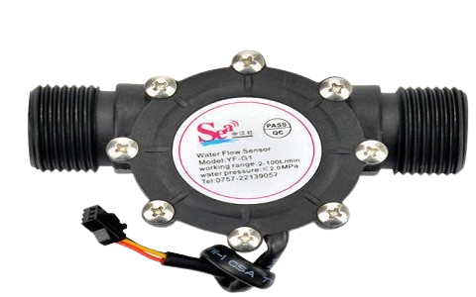

-Solenoid Valve: **Not Yet**

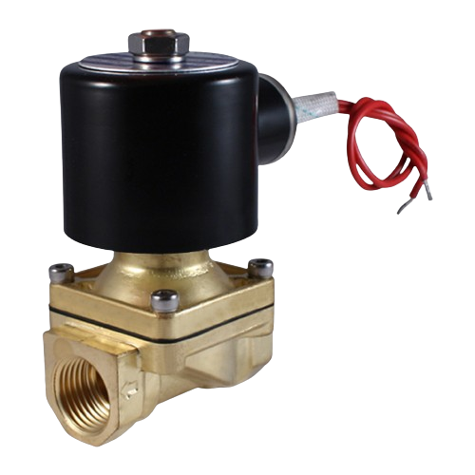

- Breadboard + Jumpers (Wires): **Available**

- Relay Module:  **Available**

- water Valve: **Not Yet**

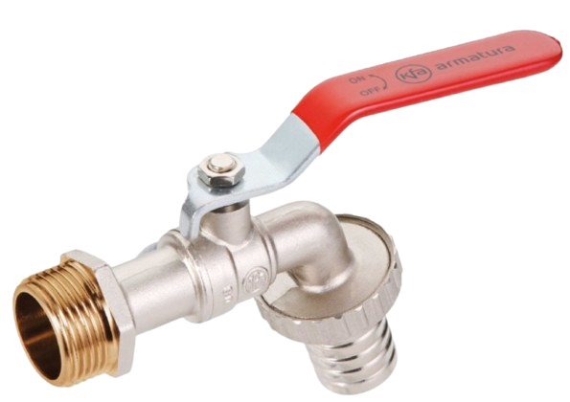

- 70 cm – 1 m pipe *(that will fit to the above valve)* + **Not Yet**

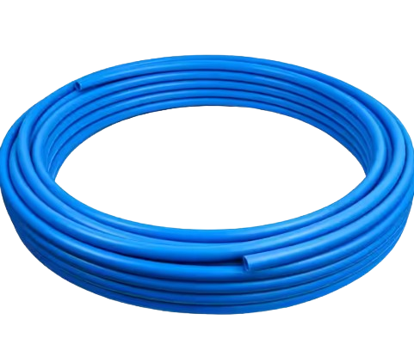

Bucket Water Jug. **Available**

Software:

Africa’s talking app and a web Hosting platform.

# Conclusion

In conclusion, the implementation of the Smart Water Meter project represents an advancement in water management and utility services in Rwanda. By introducing innovative technologies mentioned, the system will address the above challenges faced by both water supplier and consumers. Through these efforts, our aim is to enhance operational efficiency, reduce workforce requirements, improve customer satisfaction, and align with national development objectives paving the way for sustainable and efficient water resource management in Rwanda and beyond.

# Reference

|  |  |
| --- | --- |
| [1] | A. Twahirwa, National Institute of Statistics of Rwanda, 23 septermber 2027. [Online]. Available: https://statistics.gov.rw/publications/article/access-potable-water-increased-over-last-five-years-rwanda. |
| [2] | Rwanda Water Resources Board, 07 february 2021. [Online]. Available: https://www.rwb.rw/. |
| [3] | J. Griggs, "What is the Agile methodology?," Atlassian, 21 july 2014. [Online]. Available: https://www.atlassian.com/agile#:~:text=What%20is%20the%20Agile%20methodology,READ%20ON%20BELOW. [Accessed 05 march 2024]. |
| [4] | "Developer Documentation," Africa's Talking website, 21 Feb 2010. [Online]. Available: https://developers.africastalking.com/. [Accessed March 2024]. |